Statistical Analysis of Quality of Drinking Water at Dhule Taluka

Submitted in Partial Fulfillment of Requirement for the Degree of B.Sc. Statistics, By Mr. Varade Chetan Madhukar

Submitted to


Zulal Bhilajirao Patil College ,Deopur, Dhule
Department of Statistics (2021-2022)

Certificate:

This is certify that, Mr. Chetan Madhukar Varade Students of B.Sc. Statistics at Z.B.Patil College , Dhule have successfully completed the project entitled “Statistical Analysis of Quality of Drinking Water” as a part of B.Sc. Statistics degree program under my Guidance and Supervision during the academic year 2021-2022.

Prof.Ganesh T. Pedram
Head of Department of Statistics
Z.B.Patil College Prof.Narendra S. Shivaji
Project Guide

DECLARATION:

I hereby declare that the project entitled “Statistical Analysis of Quality of Drinking Water” completed and written by me under the supervision of Mr. Narendra S. Chavan. The present work is original and performed by us and previously not from the basis for the award of degree or other similar title of this or any other University or examining body.
Mr. Varade Chetan Madhukar

Place:- Dhule
Date:- / /2022
Prof.Narendra S. Shivaji
Project Guide

Acknowledgement
On the completion of this project, we must acknowledge from the core of Our heart is none other than Prof. Ganesh.T. Pedram Head. Department of Statistics, Z. B. P. College, Dhule , project guide Mr. Narendra S. Shivaji. His generous attitude and his comments have always guided us throughout and made our work very easy.
The successful completion of our work was possible due to the help, Inspiration and guidance rendered by our project guide Mr. Narendra S. Shivaji . Under his supervision and guidance, we have learned a lot and made us Comfortable during the difficult and uneasy situations of the project work, we are thankful to him for his supportive and encouraging nature during the work.
We would like to thank Dr. R.S. Shelar and Miss.Kalyani Patil (Department of Microbiology) for their valuable guidance during the project work.
We also owe thank to all non-teaching staff of Department of Statistics and Department of Microbiology for providing us the required lab facilities.
Plase:Dhule
Date:
Mr. Varade Chetan Madhukar

Index
Sr.No. | Contents | Page No.
1 | Introduction
 | Objective of the Project
 | Purpose of the project
2 | Methodology
3 | Data and Data Description
 | Measurement of Parameters
 | Data of Bisleri water bottle
4 | Data Analysis
 | Descriptive Statistics
 | Fitting of Distribution
 | Chi-square Test
 | Hypothesis
 | Equality of means
5 | Conclusion
6 | References and Software Used

Introduction: -
A simplified technical producer for analysis and assessing drinking water quality problems in villages distributed networks has been developed. The technique has been developed for use by water resource managers in reasons were conventional laboratory base drinking water quality. The water quality analyzing strategy which utilizes low cost portable instrumentation that can largely be used by non-specialist technical staff and reduces the need for costly laboratory. The instrumentation comprise recently developed field kits can provide With decreasing amount of water recourses are available decline levels of water quality as pollution increases and increasing burden to growth of population there is urgent need for the authorities responsible for distribution of drinking water resources to become aware of growing importance of drinking water and quality in the management their resources. Water is essential to sustain life and a satisfactory supply must be available to all Improving access to safe drinking water can result in tangible benefits to health. Every effort should be made to achieve of drinking water quality as safe as practicable.
Water quality can be defined as the chemical physical and biological characteristics of water, usually in respect to its suitability for a designed. Water can be used for recreation. drinking, fisheries, agriculture or industry. Each of these designated uses has different chemical physical and biological standards necessary to fulfill the respective purpose. For example, there are stringent standards for to be used for drinking or swimming compared to that used in agriculture or industry. After many years of research, water quality standard is put in place to ensure the suitability of efficient use of water for the designated purpose Water quality analysis is to measure the required parameters of water following standard methods to check whether they are in accordance with the standard.
Water quality analysis is required mainly for monitoring purpose. Some importance of such assessment includes.
1) To check whether the water quality is in compliance with the standards, and hence, suitable or not for the designated use.
2) To monitor the efficiency of a system, working for quality maintenance.
3) To check weather up gradation/change of an existing system is required and to decide what changes should take place.
4) To monitor weather water quality is in compliance with rules and regulations water quality analysis is of extremely necessary in the sectors of:
1. Public Health (especially for drinking water)
2. Industrial use
Drinking water which should be palatable is essential to health and welfare of community and water from all sources must have some form of purification before consumption about 1.2 billion people still lack safe drinking water and more than 6 million children die from diarrhea in developing countries every year. Water borne diseases still kill on the average 25000 people every day in developing countries while millions suffer the debilitating effects of these diseases. Poor drinking water quality is the global health crisis with many layers of complexity not everyone who must help remedies this monumental problem is a scientist or a policymaker or water sanitation and hygiene expert or public health professional. However, everyone involved with this challenge at every level must have some understanding of the subject and science behind it.
The amount of drinking water required is variable it depends on physical activity. health, age and environmental conditions in a temperate climate under normal conditions. The adequate water intake is about 2.7liters, for adult women and 3.7 liters for adult men. Physical exercises and fit exposure cause loss of water and therefore may induce thirst and greater water intake. According to World Health Organization's 2021 report safe drinking water is water that does not represent any significant risk to health over a lifetime of consumption including different sensitive that may offer between life stages". Drinking water is also known as potable water.

Purposes of quality of drinking water:
1) Water is essential to life and a nominal supply of clean safe drinking water is required for the sentences of life.
2) Today, in developed nations, it is standard practise to provide the populace with safe reliable recognized as a basic human right and cost-effective measure of reducing disease (i.e... preventative medicine).
3) In developed countries, drinking water quality guidelines and regulations are based on current, published scientific research related to health effect, aesthetic effect.
4) All these important parameters ain at providing potable and palatable drinking water to reduce water borne diseases and foster healthy living .
5) The purpose of having drinking water quality guidelines and regulation is to ensure that all human beings within a country have access to safe drinking water.
6) In developing countries, it is estimated that over 80% of disease is caused by contaminated drinking water.
7) Water is largely the cause of most disease and a considerable amount of work potential is compromised because of this
8) The purpose of our project is to analyze the quality of drinking water in villages of Dhule Taluka .
Objective of quality of water
As the water affects the health of the public in different ways, hence the study of quality of drinking water is important. The continuously growing population is putting additional pressure on the water resources and threatening the quality of water. So, the present study has been planned to analyses the quality of drinking water in villeages of Dhule Taluka is supplied drinking water from different sources. The sources of drinking water are.
(i) L.PH supply (Govt. supply)
(ii) Ground water supply (Hand pump and Spring waters)
The present study has the following objectives
1) Survey of drinking water sources and identification of water related problems faced by the public in villages of Dhule Taluka
2) Collection of samples from different water sources and study the quality of drinking water seasonally, yearly and comparison with National and WHO)-quality standards.
3) to spread awareness among the public regarding quality of water drinking water regulations and the potential health risks associated with the use of contaminated water.
4) All these important parameters aim of providing potable and palatable drinking water to reduce water borne diseases and foster healthy living
5) Priority is given to the reduction of pollution and the conservation of waters in their natural state and the restoration of water quality taking into account the necessary water uses in addition to an improvement of water quality, water.
Quality characteristics of Drinking Water :-
1)Conductivity
2) pH
3) TDS (total dissolved solid)
4) Solubility
5)Density
6) Surface tension
7) Viscosity
8) Thermal capacity
9) Salinity (concentration of dissolved salt)
10) Capacity
11) Specific conductivity
Out of these characteristics of drinking water we can check the only 3 characteristics without any cost.
1) pH
2) Conductivity
3) TDS

PH :-
The quality of drinking water is measured by various measurements. pH is a measurement of electrically charged particles in a substance. It indicates how acidie or alkaline (basic) that substance is If water has pH is less than 7 then water is present in the form of base(basic), or greater than 7 then water is present in the form of acid(acidic). If water has pH is very high then the drinking water is very dangerous to our health, that is alkalinity is present in the water, and also the pH is less than 7 then it becomes basic water which is not pure for drinking water. Pure water has pH of 7 that it is neutal pH for drinking water.
The recommended range for pH is 0:14.(World Health Oraganization). Freshwater pH varies across the world depending on weather patterns, human activity. and natural processes.
Water with a very low or high pH can be a sign of chemical or heavy metal pollution. Water that doesn't fall in the "safe" pH range of 6.5 to 8.5, particularly if it's alkaline isn't necessarily unsafe. However, very alkaline water can have an unpleasant smell or taste, and it can also damage pipes and water-carrying appliances. Alkaline water has a higher pH level than regular drinking water. Alkaline water typically has a pH of 8 or 9.

Side Effects of Alkaline Water
- Nausea
- Vomiting
- Hand tremors
- Muscle twitching
Effects of High pH:
When water having higher pH is 8 to 9 then following diseases are occurred.
- Asthma
- Obesity
- Problems with Nervous System
- Kidney problem
- Diarrhoea
Drinking Water Levels:
Type of Water | pH levels
Tap Water | Varies typically about 7.5
Distilled Water | 5 to 7
Common Bottle Water | 6.5 to 7.5
Bottle Water label as alkaline | 8 to 9
Ocean Water | About 8
Acid Rain | 5 to 5.5

Importance of pH:-
pH is important for check whether the quality of drinking water. The necessary pH for drinking water is 7. But the if it is greater than 7 then the drinking water have higher pH and the waterwater is involves in acidic manner. Or if the pH of drinking water is less than 7 then the water is convert into basic form. If we drink more alkaline water will have your dentist smiling because acidity from beverages is a leading cause of tooth decay. Each number on the pH scale is ten times more or less than the next level.
A pH level of 6 is 10 times more acidic than neutral and level of 5 is 100 times more acidie! The jump between 5 and 6 may not sound like much of a difference, but it does accelerate quickly. A pH level of 14 is 10.000.000 times more alkaline than a level of 7. Below is an example of some common household items and where they fall on the pH scale.

Effects of Low pH:-
If water has low pH i.e. ranges from less than 7:
The low pH can affect on human body quickly. Many diseases are start from quality of drinking water. The drinking water has pH is present in between 6.5 to 8.5 on a scale that ranges from 0 to 14. "The best pH level for drinking water sits right in middle at a 7 Water with very high and low pH can be sign of chemical or heavy metal pollution. Now, we are discussed the diseases cause due to low pH.
1) Heart Failure 2) Low Blood sugar 3) Cancer 4) Liver Failure
If we drinking the higher level of pH then it is harmful to our health.

Conductivity
Conductivity is traditionally determined by connecting the electrolyte in a Wheatstone bridge. In the SWMP data a higher conductivity value indicates that there are more chemicals dissolved in the water. Conductivity measures the water's ability to conduct electricity. Because dissolved salts and other inorganic chemicals conduct electrical current conductivity increases us salinity increases High quality deionized water has a conductivity of about 5.5 µS/m at 25 °C. typical drinking water in the range of 5-50 mS/m. while sea water about 5 S/m (or 5,000.000 µS/m). Conductivity is usually measured in micro or milli Siemens per/cm also it reported in micromhos or millimhos/cm microsiemens/cm is standard unit for measurement of fresh water.
Conductivity of electrolytes depends on-Concentration usually expressed in mg/I. at low concentrations conductivity increases with the square root of concentration Temperature - the higher the temperature the higher the mobility of ions, hence the conductivity.

Need to Measure Conductivity:
In lab settings, water conductivity needs to be measured because researchers and scientists need to know the exact composition of the water they're experimenting with in order to get accurate, repeatable results. This is why purified water is so common in the pharmaceutical, semiconductor, and solar industries Water conductivity, however, has major implications on several other industries, too.

Importance
Conductivity measures water's ability to conduct electricity due to the presence or absence of certain ions. While pure water conducts electricity poorly, water that has certain chemicals or elements in it, and at varying amounts including sodium, magnesium, calcium. and chloride is a better conductor of electricity. Distilled water has a conductivity ranging from 0.5 to 3 µS/cm. while most streams range between 50 to 1500 µS/cm. Freshwater streams ideally should have a conductivity between 150 to 500 µS/cm to support diverse aquatic life.

Affects
Conductivity in water is affected by the presence of inorganic dissolved solids such as chloride, nitrate, sulphate, and phosphate unions (ions that carry a negative charge) or sodium, magnesium, calcium, iron, and aluminum cations (ions that carry a positive charge). The more ions that are present, the higher the conductivity of water.
Distilled or deionized water can act as an insulator due to its very low (if not negligible) conductivity value Sea water, on the other hand, has a very high conductivity. lons conduct electricity due to their positive and negative charges. If the conductivity of water increases then it is very harmful to our human health, because it produces many harmful diseases. The conductivity of our drinking water is very high then it affected by other diseases.
TDS
Total Dissolved Solids (TDS) in water are some organic and inorganic materials. which include minerals and ions that are dissolved in a particular quantity in water. When water passes through stones, pipes or different surfaces, the particles are absorbed into the water. The water that you receive exceeds the maximum level of TDS that needs to be present in water.

Importance of TDS
Water that has a TDS level of more than 1000me L is unfit for consumption. A high level of TDS in water can lead to a number of health problems. The presence of potassium, sodium, chlorides increases the TDS level in the water. The recommended range of TDS for drinking water is 300mg/L to 500mg/L (Bureau of Standards). However, the presence of toxic ions such as lead, nitrate. cadmium, and arsenic present in water can lead to a number of serious health problems. This is especially important for children because they are much more sensitive to contaminants because their defines systems have not fully developed. The purer the water, one can be assured of good health. KENT provides the best water purifiers in India that come with a TDS controller to ensure that the water you drink is completely safe for consumption IDS measured hardness of water

Safe Level of TDS for Drinking Water
The table mentioned below provides a permissible range of TDS in drinking water and reasons for why the TDS level mentioned in water is not acceptable for drinking:
TDS Level (Milligram/Litter) | Remarks
Less than 50 | Unacceptable as it lacks essential minerals
50 -150 | Acceptable for drinking. The TDS level is ideal for areas where the water polluted by sewage or industrial waste
150-250 | Good. The water is ideal for people with cardiovascular disease
250-350 | Good. The water is ideal for people with cardiovascular disease
350-500 | Fairly acceptable
500-900 | Less acceptable
900-1200 | Least acceptable. Avoid drinking water which has a TDS level of 900
1200-2000 | Water is not acceptable for drinking
Above 2000 | Unacceptable

A TDS test helps in determining the total amount of dissolved solids present in water. However, it doesn't identify any individual compounds, the sources. As a result, it is essential to conduct some additional tests to determine the contaminants in water.

Ways to Reduce or Remove TDS in Water
1. Reverse Osmosis (R.O.)
Reverse Osmosis removes TDS by forcing the water, under pressure, through a synthetic membrane. The membrane contains microscopic pores which will allow only molecules smaller than 0.0001 microns to pass through as the molecules of dissolved metals and salts are large compared to the water molecules, water squeezes through the membrane leaving the metals and salts behind,
2. Distillation
The process involves boiling water to produce water vapour. The water vapour rises to a cool surface where it is condensed back into the liquid form. The dissolved salts are unable to vaporize and remain in the boding solution.
3. Deionisation (DI)
In this process, water is passed through a positive and negative electrode. The ion selective membranes enable the positive ions to separate from the water and move towards the negative electrode. The end result is de-ionized water with high purity. However, the water is first passed through a reverse osmosis unit first in order to remove the nonionic organic contaminants

Side Effects of TDS on Drinking Water
1) Vomiting 2) Kidney problem 3) Cholera 4) Malaria 5) Obesity

Other Characteristics of Drinking Water: Solubility:
It is a chemical property refer into ability for a given substance the solute to
Temperature
1)Polarity 2)Pressure 3) Molecular Size
These can be explain as
1) Temperature: Basically, as solubility increases with temperature.
2) Polarity: In most cases solutes dissolve in solvents that have a similar polarity.
3)Pressure: Solids, liquid solutes don’t affect by pressure.

Descriptive Level | Levels
Very Soluble | Less than 1
Fairly Soluble | Less from 1 to 10
Soluble | From 10 to 30
Sparingly Soluble | From 30 to 100
Very Slightly Soluble | From 100 to 1000
Practically Soluble or insoluble | From 1000 to 10000

1) Thermal Conductivity
The conductivity of water measure of capability of water to pass electrical flow. It is directly proportional to concentration of ions present in the water when temperature is increasing the conductivity of water is also increase high quality deionise water has a conductivity about 5.5 micro-Siemens at room temperature.
Typical drinking water in the range 5 to 50 (MS/m) while sea water about 5(m/m) conductivity is traditionally determined by collecting electrolytes in the wheat stone bridge
Importance:
Pure water is not a good conductor of electricity because the current is transported by ions in solution. The conductivity increases as the concentration of ions increases. Apart from liquid metals water has the highest thermal conductivity of any liquid for most liquid thermal conductivity falls with increasing temperature but this occurs only about 130 degree Celsius in water.

Types of Water | Conductivity Level
Distilled water | 0.05 us/m
Drinking water | 50 us/m
Rain water | 200 to 800 us/cm
Sea water | 2 to 100 us/cm

2) Specific Conductivity
Specific conductivity is a measure of how well water can conduct an electrical current. As it increases with arising amount and mobility of ions. These ions are which come from the breakdown of compounds conduct electricity because they are negatively or positively charge when dissolved in water. The acceptable specific conductivity for pure and distilled water has a conductivity of 0.05 us/cm, which corresponds to a resistivity of 18: mega ohm-cm seawater, has a 50 MS/cm and drinking water has a conductivity of 200 to 800 us/cm. Freshwater streams ideally should have a conductivity between 150 to 500 us/sm support diverse aquatic life.
Importatice
Specific conductivity measures water ability to conduct electricity due to the presence or absence of certain ions. While pure water conducts electricity poorly, water that has certain chemicals of elements in it, and at varying amounts including sodium, chloride is a better conductor of electricity. As the temperature of water affects the conductivity at about 25 degree Celsius allows the data to be compared easily, the specific conductivity is basically reported in ns/cm at about a temperature measuring 25 degree Celsius. But, it can be harmful when taken more than the desired amount needed by the body indicator of water quality. It is denoted by s or k . The SI unit Siemens Per Meter and Milliohms per Centimetre.

Methodology

Beings Water is essential for the survival of life. On an average a human Safe and clean drinking water is basic need for health and also right of human being consumes about two liters of water every day during his whole life period . The water pollution by various sources has become a major concern for the welfare of mankind. Therefore, the quality of water has to be analyzed. For this, purpose we have selected the following water sampling stations 1. pH 2. Conductivity 3. TDS
Terms used in Methodology
1) Data Analysis 2) Descriptive Statistics 3) Hypothesis 4) Equality of mean test

Given Data:-
Sr.No: | Name of Villages | Temp.© | pH | TDS | Conductivity
01 | Behed | 24 | 7.5 | 537 | 573.8
02 | Lamkani | 24 | 7.4 | 674 | 481.6
03 | Sitane | 23 | 7.3 | 523 | 848.7
04 | Shirdhane | 24 | 7.5 | 471 | 629.4
05 | Boris | 23 | 7.4 | 762 | 379.4
06 | Ner | 25 | 7.4 | 966 | 399.6
07 | Deur | 25 | 7.4 | 713 | 446.5
08 | Lonkhedi | 25 | 7.3 | 655 | 461.0
09 | Burzad | 25 | 7.7 | 537 | 819.2
10 | Udane | 24 | 7.2 | 578 | 636.6
11 | Nikumbhe | 24 | 7.4 | 390 | 534.0
12 | Nandale | 24 | 7.3 | 937 | 987.3
13 | Aashti | 24 | 7.4 | 803 | 541.8
14 | Deobhane | 24 | 7.7 | 968 | 457.6
15 | Songir | 23 | 7.2 | 368 | 641.6
16 | Dapura | 23 | 7.5 | 543 | 781.3
17 | Dhanur | 24 | 7.7 | 593 | 986.2
18 | Satarne | 24 | 7.3 | 794 | 462.2
19 | Shirdhane | 22 | 7.8 | 471 | 637.3
20 | Kundane | 24 | 7.2 | 538 | 790.5
21 | Nagaon | 24 | 7.5 | 991 | 556.4
22 | Nandane | 24 | 7.8 | 960 | 829.6
23 | Balapur | 24 | 7.2 | 486 | 464.9
24 | Mukati | 24 | 7.4 | 878 | 677.7
25 | Fagne | 24 | 7.1 | 637 | 647.7
26 | Ajang | 24 | 7.3 | 717 | 463.6
27 | Pimpri | 23 | 7.3 | 519 | 615.8
28 | Wadel | 23 | 7.5 | 407 | 459.6
29 | Saundane | 23 | 7.6 | 977 | 991.1
30 | Babhulwadi | 23 | 7.5 | 523 | 711.8
31 | Borvihir | 23 | 7.2 | 465 | 750.4
32 | Shirud | 25 | 7.5 | 496 | 506.4
33 | Narvhal | 23 | 7.2 | 681 | 779.3
34 | Tikhi | 23 | 7.3 | 869 | 548.6
35 | Vinchur | 23 | 7.5 | 692 | 750.8
36 | Laling | 23 | 7.3 | 947 | 775.5
37 | Arvi | 23 | 7.5 | 837 | 741.5
38 | Anakwadi | 24 | 7.7 | 467 | 640.1
39 | Moghan | 24 | 7.1 | 665 | 465.1
40 | Daulatpada | 24 | 6.8 | 968 | 489.5
41 | Morshevadi | 24 | 7.8 | 943 | 751.4
42 | Junner | 22 | 7.5 | 463 | 561.4
43 | Sadgaon | 22 | 7.7 | 497 | 478.5
44 | Chaugaon | 22 | 7.7 | 940 | 725.3
45 | Khede | 22 | 7.1 | 962 | 570.4
46 | Kusumbe | 24 | 7.3 | 544 | 493.7
47 | Bhadane | 22 | 7.3 | 968 | 568.3
48 | Nimdale | 23 | 7.6 | 390 | 613.7
49 | Deopur | 22 | 7.7 | 316 | 768.2
50 | Dhule | 21 | 7.7 | 413 | 837.6
Bisleri Water Bottle Sample :-
 | pH | TDS | Conductivity
Bisleri Water | 7.1 | 121.54 | 42.86
Data Analysis :-
Descriptive Statistics value:-
 | pH | TDS | Conductivity
Mean | 7.426 | 668.78 | 634.59
Variance | 0.04727 | 43825.69 | 25042.5
Standard Deviation | 0.21742 | 209.35 | 158.25

pH (LogNormal Distribution ):-
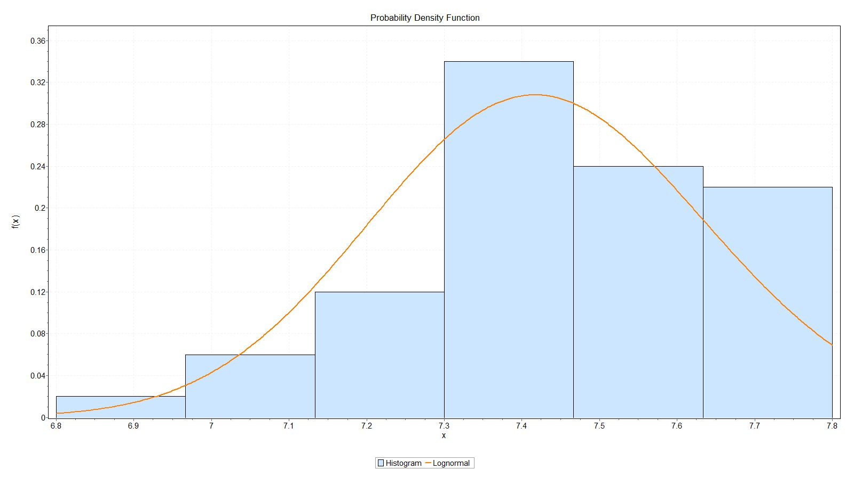

Chi-Squared
Deg. Of Freedom  Statistic  P-Value  Rank | 5  3.2575  0.9686  12
Signi. Level | 0.2 | 0.1 | 0.05 | 0.02 | 0.01
Critical Value | 7.2893 | 9.2364 | 11.07 | 13.388 | 15.086
Reject(yes or No) | No | No | No | No | No
σ=0.0291 , μ=2.0046

TDS ( Gamma Distribution):-

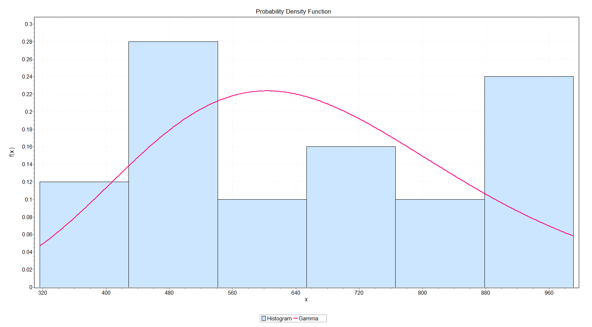

Chi-Squared
Deg. Of Freedom  Statistic  P-Value  Rank | 4  2.5394  0.7248  2
Signi. Level | 0.2 | 0.1 | 0.05 | 0.02 | 0.01
Critical Value | 5.9886 | 7.7794 | 9.4877 | 11.668 | 13.277
Reject(yes or No) | No | No | No | No | No
α = 10.206 , β = 65.531

Conductivity (Normal Distribution):-
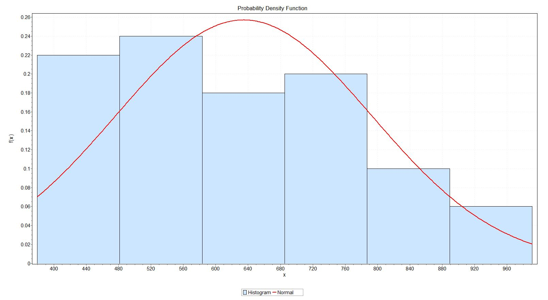

Chi-Squared
Deg. Of Freedom  Statistic  P-Value  Rank | 5  4.3558  0.9988  11
Signi. Level | 0.2 | 0.1 | 0.05 | 0.02 | 0.01
Critical Value | 5.9886 | 7.7794 | 9.4877 | 11.668 | 13.277
Reject(yes or No) | No | No | No | No | No
σ=158.25 , μ=634.59

Hypothesis:-
PH:
HO: Average value of pH in villages,
HI: pH of bisleri water bottle.
N | Mean | C.I. | Z | P-value
50 | 7.426 | (7.366,7.486) | -0.16 | 0.87914

Result:
P value =0.87914
P value> 0.05
Then accept hypothesis
Conclusion: According average of pH water is safe to drink.

Conductivity:
HO: Average value of conductivity in villages.
H1: conductivity of bisleri water bottle
N | Mean | C.I. | Z | P-value
50 | 634.59 | (590.73,678.45) | 12.40 | 0.00006

Result: P value= 0.00006 P value < 0.05 Then reject hypothesis.
Conclusion: According to average value of conductivity is not equal to conductivity of Bisleri water bottle. Then according to conductivity water is unsafe to drink.

TDS: HO: Average value of TDS in villages. H1: TDS of bisleri water bottle.
N | Mean | C.I. | Z | P-value
50 | 668.78 | (610.75,726.81) | 16.41 | 0.00001
Result: P value= 0.000015 P value < 0.05 Then reject hypothesis.
Conclusion: According to average value of TDS is not equal to TDS of Bisleri water bottle. According to is range of TDS is 300mg/l. to 500 mg/l.. the quality of drinking water is unsafe.

Conclusion:

On the basis of findings it is concluded that drinking water of our study area are satisfy chemical parameters, these parameters are efficient for testing the quality of drinking water. All the samples in our study area also consistent with World Health Organization(WHO) for standard of drinking water. We compare the average value of 3 parameters (pH, TDS ,Conductivity. ) with values of Bisleri water, from this comparison we conclude that drinking water of villages in Dhule Taluka is unsafe as compare to our Bisleri water. Because the value of TDS of villages drinking water is very high as compare to Bisleri water. So, the overall conclusion is the Bisleri water is best for drink.
But the value of TDS of Nagaon(991) and Saundan (977) is very high as compare to recommended range of TDS(300ms-500ms) by WHO. Then water is unsafe to drink. High TDS can causes the Kidney diseases.

References :-
- Websites:
https://en.wikipedia.org/wiki/Water_quality
https://www.who.int
https://www.bisleri.com
https://www.researchgate.net

- Project:
Water Quality Status of India 2019-2020
Water of Quality Control of Maharashtra 2018-2019.

- Software:
Excel
Easy Fit

